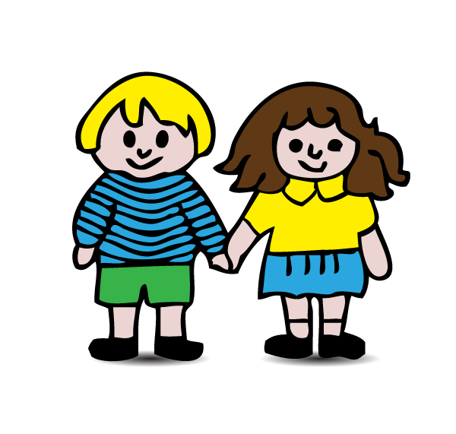

I LIKE TO PLAY THE CLAVES
I like to play the claves
1,2,3,4.
Play them very quietly
1,2,3,4.
Any type of weather
When we play together
I like to play the claves.
HIGGLEDY PIGELDY RHYME
Higgeldy Pigeldy buttercup
How many fingers do I hold up?
5 it is and 5 you say
Please hold up 5 for us today!
OR
Higgledy Pigledy buttercup
How many fingers do I hold up?
4 it is and 4 you say
Please shake 4 for us today!
OR
Higgledy Pigledy buttercup
How many fingers do I hold up?
6 it is and 6 you say
Please clap 6 for us today!
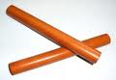

BANG YOUR DRUM WITH ME
(To tune of The Muffin Man)

Bang your drum along with me
Along with me
Along with me
Bang your drum along with me
1,2,3.

Shake your shakers along with me
Along with me
Along with me
Shake your shakers along with me
1,2,3.

Tap your claves along with me
Along with me
Along with me
Tap your claves along with me
1,2,3.

You might like to know these songs and rhymes so that you can join in with your child at home. We do them together as class groups in school. Repetition of them can help to develop speech and language, memory skills, listening skills, awareness of rhyming words and a sense of rhythm. Most important of all, they are for fun, so enjoy them with your child. We realise that you will not know all the tunes but we hope that your child will be able to help you out with these!
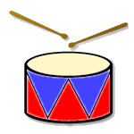

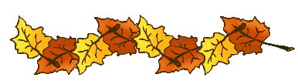

THE CLEVER LITTLE SQUIRREL
(Tune: The Grand Old Duke of York)

The clever little squirrel,
He gathers nuts and seeds.
He hides them for the winter months
So he’ll have all he needs.

Oh up-up-up he goes
And down-down-down he comes
He runs around, goes up and down
His work is never done.

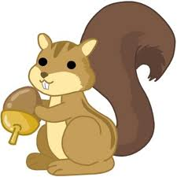

WE’RE GETTING LOTS OF EXERCISE
(Tune: The Farmer Wants a Wife)

We’re jumping up and down,
We’re jumping up and down,
We’re getting lots of exercise,
We’re jumping up and down.

Other verses: 
- We bend and touch our toes....
- We stretch up to the sky....
- We wave from side to side....

VEGETABLE SONG
(Tune: Twinkle, Twinkle)

Carrots, onions, beans and peas
We are very fond of these.
Cucumber and celery
Make us grow so healthily.
Cabbage, corn and cauliflower
Give our muscles lots of power.
THE FRUIT SONG
(Tune: How did Moses Cross the Red Sea)

We like apples and bananas,
We like oranges and grapefruit,
We like grapes and pears and kiwi
And they’re all very good for us.

Very, very, very good for us,
Very, very, very good for us,
Very, very, very good for us,
And they’re all very good for us.

HUMPTY DUMPTY SAT ON A WALL

Humpty Dumpty sat on a wall
Humpty Dumpty had a great fall
All the king’s horses and all the king’s men
Couldn’t put Humpty together again.

Humpty Dumpty sat on the ground
Humpty Dumpty looked all around
Gone were the chimneys and gone were the roofs
All he could see were buckles and hooves.

Humpty Dumpty counted to 10
1,2,3,4,5,6,7,8,9,10
Humpty Dumpty got up again
All the king’s horses and all the king’s men
Were happy that Humpty’s together again!

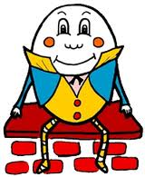

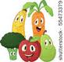
A LITTLE RED SQUIRREL (poem)

A little red squirrel as busy as can be,
Plays on a branch of a tall forest tree,
He likes to eat acorns and nuts even more,
And hides them away for his own winter store.
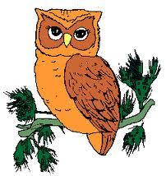
FIVE LITTLE LEAVES (poem)

Five little leaves so bright and gay,
Were dancing about on a tree one day,
The wind came blowing through the town,
And one little leaf came tumbling down.

Four little leaves....
THE WIDE EYED OWL (poem)

There’s a wide eyed owl
With a pointed nose.
He has pointed ears
And claws for toes.
He sits in a tree
And looks at you.
Then he flaps his wings
And says “Tu-whit tu-whoo!”.
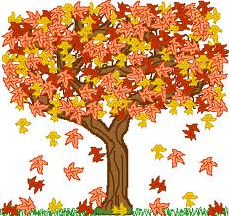
THE LEAVES ON THE TREES
(Tune: The Wheels on the Bus)

The leaves on the trees turn orange and red
Orange and red, orange and red.
The leaves on the trees turn orange and red
Now it’s autumn time.

Other verses:
- The leaves on the trees go swish, swish, swish....
- The leaves on the trees come tumbling down....
- The leaves on the ground go cruch, crunch, crunch....
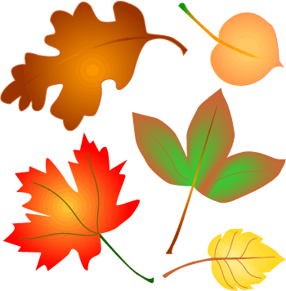
AUTUMN LEAVES
(Tune: London Bridge)

Autumn leaves are falling down,
Falling down, falling down.
Autumn leaves are falling down,
In my garden.

Listen as they crunch, crunch, crunch
Crunch, crunch, crunch
Crunch, crunch, crunch
Listen as they crunch, crunch, crunch,
In my garden.
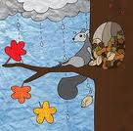


APPLE TREE (poem)

Here is the tree with leaves so green,
Here are the apples that hang between.
When the wind blows, the apples fall,
Here is the basket to collect them all.

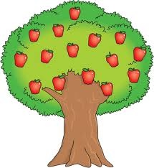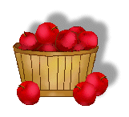

THE ACORN (poem)

If I take an acorn that’s fallen from its cup,
And plant it in the garden and never dig it up,
The sun and rain will change it to as great, big tree,
With lots of acorns on it growing, just for me!

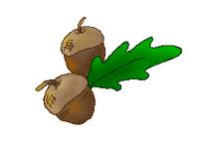
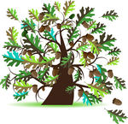
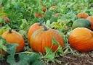
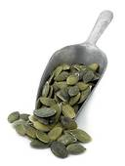
PUMPKIN POEM

One day I found two pumpkin seeds
I planted one and pulled out the weeds.
It sprouted roots and a big, long vine
A pumpkin grew; I called it mine.

The pumpkin was quite round and fat
(I really am quite proud of that).
But there is something I’ll admit
That has got me worried, just a bit.

I ate the other seed, you see,
Now will it grow inside of me?
(I’m so relieved since I have found
That pumpkins only grow in the ground!).

