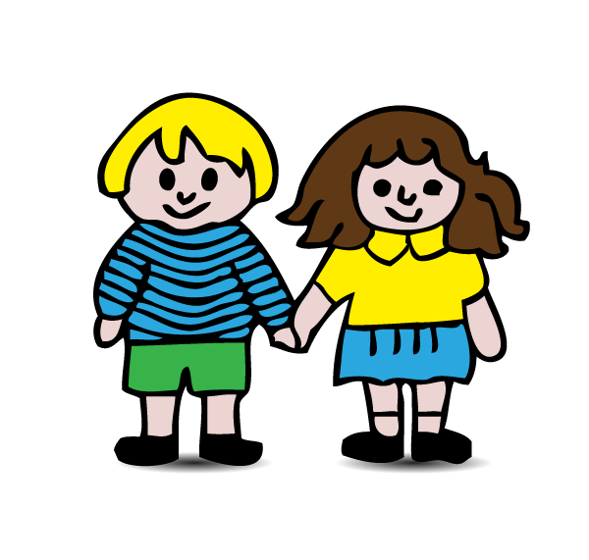


Away in a manger
Away in a manger, no crib for a bed
The little Lord Jesus laid down His sweet head
The stars in the bright sky Looked down where He lay
The little Lord Jesus asleep on the hay.
The cattle are lowing, the baby awakes But little Lord Jesus no crying He makes I love Thee, Lord Jesus, look down from the sky And stay by my side until morning is nigh.
Be near me Lord Jesus, I ask Thee to stay Close by me forever and love me I pray Bless all the dear children in Thy tender care And fit us for heaven to live with Thee there.

Jingle Bells

Jingle bells, jingle bells, jingle all the way
Oh what fun it is to ride on a one horse open sleigh
Oh, jingle bells, jingle bells, jingle all the way
Oh what fun it is to ride on a one horse open sleigh.

Dashing through the snow on a one horse open sleigh
Oe'er the fields we go, laughing all the way
Bells on Bobtail ring, making spirits bright
What fun it is to ride and sing our sleighing song tonight.

Oh, jingle bell, jingle bells ...

You might like to know these songs and rhymes so that you can join in with your child at home. We do them together as class groups in school. Repetition of them can help to develop speech and language, memory skills, listening skills, awareness of rhyming words and a sense of rhythm. Most important of all, they are for fun, so enjoy them with your child. We realise that you will not know all the tunes but we hope that your child will be able to help you out with these!
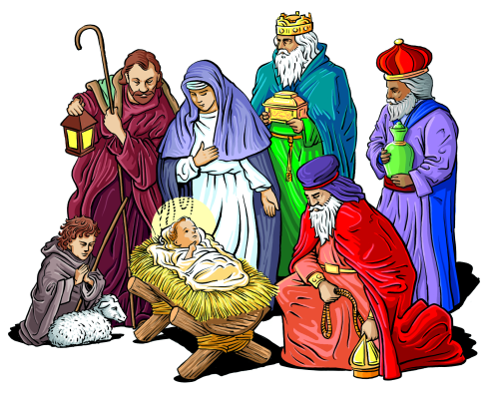
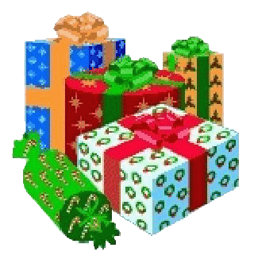

Santa
(Tune: "She'll Be Coming Round the Mountain")
He'll be driving eight brown reindeer when he comes,
He'll be driving eight brown reindeer when he comes,
He'll be driving eight brown reindeer,
He'll be driving eight brown reindeer,
He'll be driving eight brown reindeer when he comes.
He'll be piled up with toys when he comes,
He'll be piled up with toys when he comes,
He'll be piled up with toys,
For all the girls and boys.
He'll be piled up with toys when he comes.
He'll be dressed all in red when he comes,
He'll be dressed all in red when he comes.
He'll be dressed all in red,
From his toes up to his head,
He'll be dressed all in red when he comes!

Snowflakes

Snowflakes falling, snowflakes falling
Falling on to me.
Snowflakes falling, snowflakes falling
Beautiful to see.
Gliding down, all around,
Winter's carpet on the ground.

Big Square Present
There’s a big square present Underneath the Christmas Tree There’s a big square present I wonder what it can be? I wonder what it can be?
There’s a big round present Underneath the Christmas Tree There’s a big round present I wonder what it can be? I wonder what it can be?
There’s a big rectangle present Underneath the Christmas Tree There’s a big rectangle present I wonder what it can be? I wonder what it can be?
There’s a big triangle present Underneath the Christmas Tree There’s a big triangle present I wonder what it can be? I wonder what it can be?
There’s a big knobbly present Underneath the Christmas Tree There’s a big knobbly present I wonder what it can be? I wonder what it can be?

I'm A Little Pine Tree
(Tune: I’m a Little Teapot)
I'm a little pine tree as you can see,
All the other pine trees are bigger than me.
Maybe when I grow up then I'll be
A great big merry Christmas tree!

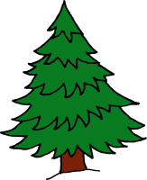
Father Christmas
(Tune – Frère Jacques)
Father Christmas, Father Christmas He got stuck, he got stuck Coming down the chimney Coming down the chimney What bad luck, what bad luck!

Jesus' birthday
A long time ago a baby boy was born (x3)
And his name was Jesus.
Chorus
Oh Jesus, soon it's your birthday,
Jesus soon it's your birthday,
Jesus soon it's your birthday
On the 25th of December.

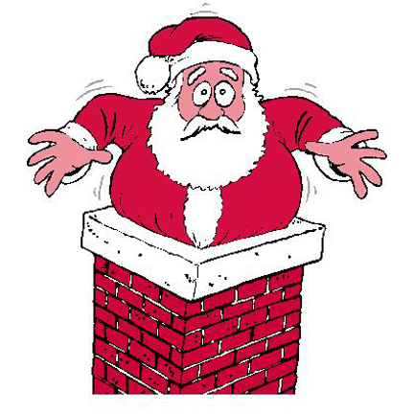
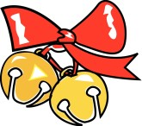
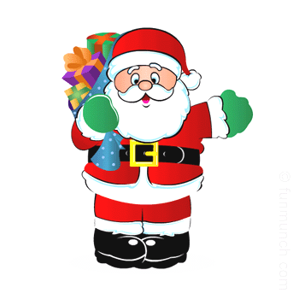
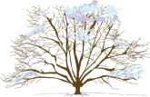

Trees in winter

In winter lots of trees are bare
No leaves are to be seen
But other trees still have their leaves
And they're called evergreen.

Can you hear the sleigh bells?
Can you hear the sleigh bells? Ching, ching, ching, ching, ching Santa Claus is on his way Ching, ching, ching, ching, ching
A great big sack on his back With lots of presents for me A great big smile on his face And a ho, ho, ho, hee, hee, hee
Can you hear the sleigh bells? Ching, ching, ching, ching, ching Santa Claus is on his way Ching, ching, ching, ching, ching

Santa Song
(Tune: I'm a Little Teapot)
I'm a little Santa short and fat,
Here is my beard and here is my sack,
On Christmas Eve I hop in my sleigh,
With a "Ho ho ho" I'm on my way.

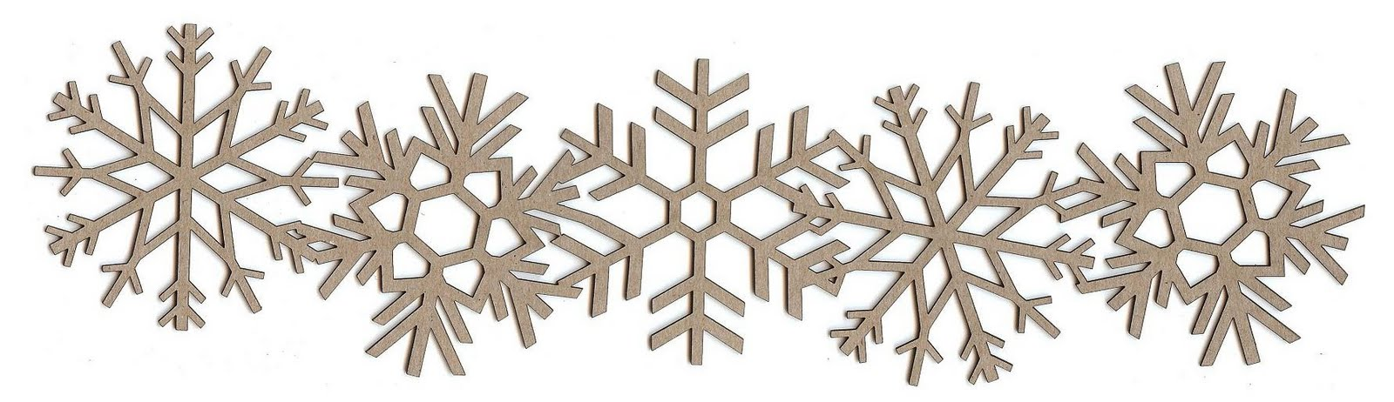

Falling Snow
See the pretty snowflakes
Falling from the sky;
On the wall and housetops
Soft and thick they lie.
On the window ledges,
On the branches bare;
Now how fast they gather,
Filling all the air.
Look into the garden,
Where the grass was green;
Covered by the snowflakes,
Not a blade is seen.
Now the bare black bushes
All look soft and white,
Every twig is laden,
What a pretty sight!

Twinkle, twinkle Christmas star
Twinkle, twinkle Christmas star, how I wonder what you are.
Up above the cattle stall, bringing good news to us all.
Twinkle, twinkle Christmas star, how I wonder what you are.
Twinkle, twinkle Christmas star, how I wonder what you are.
On the top of the Christmas tree, you look happy as can be.
Twinkle, twinkle Christmas star, how I wonder what you are.

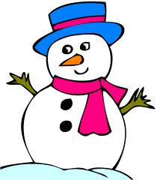
I'm a Little Snowman
I'm a little snowman round and fat,
Here are my mittens,
Here is my hat.
Add a little scarf and a carrot nose,
I stand so tall when the cold wind blows.

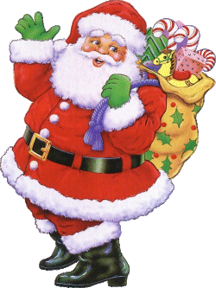
S-A-N-T-A
(Tune: B-I-N-G-O)
I know a man with a long white beard
And Santa is his name-o
S-A-N-T-A
S-A-N-T-A
S-A-N-T-A
And Santa is his name-o
He slides down the chimney with a pack on his back
And Santa is his name-o
S-A-N-T-A
S-A-N-T-A
S-A-N-T-A
And Santa is his name-o
Eight little reindeer pull his sleigh
And Santa is his name-o
S-A-N-T-A
S-A-N-T-A
S-A-N-T-A
And Santa is his name-o

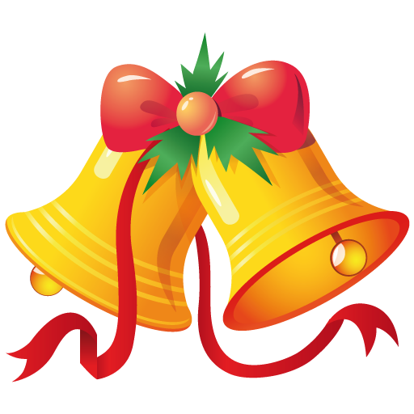
Ring Those Bells
(Tune: She’ll Be Coming Round the Mountain)
(Loudly)
We will ring those Christmas bells so loud and clear.
We will ring those Christmas bells so loud and clear.
We will hear the dingle, dangle
When they jingle, jingle, jangle.
Yes, we'll ring those Christmas bells so loud and clear.
(Softly)
We will ring those Christmas bells so quietly.
We will ring those Christmas bells so quietly.
We will hear the dingle, dangle
When they jingle, jingle, jangle.
Yes, we'll ring those Christmas bells so quietly.
(loud and deliberate)
We will ring those Christmas bells so fast and loud.
We will ring those Christmas bells so fast and loud.
We will hear the dingle, dangle
When they jingle, jingle, jangle.
Yes, we'll ring those Christmas bells so fast and loud.

