Thursday 15th December 2011 Harrison News Issue 7


Christmas creativity...
All the children enjoyed writing their Christmas cards, decorating them & the envelopes! We all walked to the post box and posted them. It was a really exciting & fun activity & we hope that you enjoyed receiving them as much as the children enjoyed making & posting them.
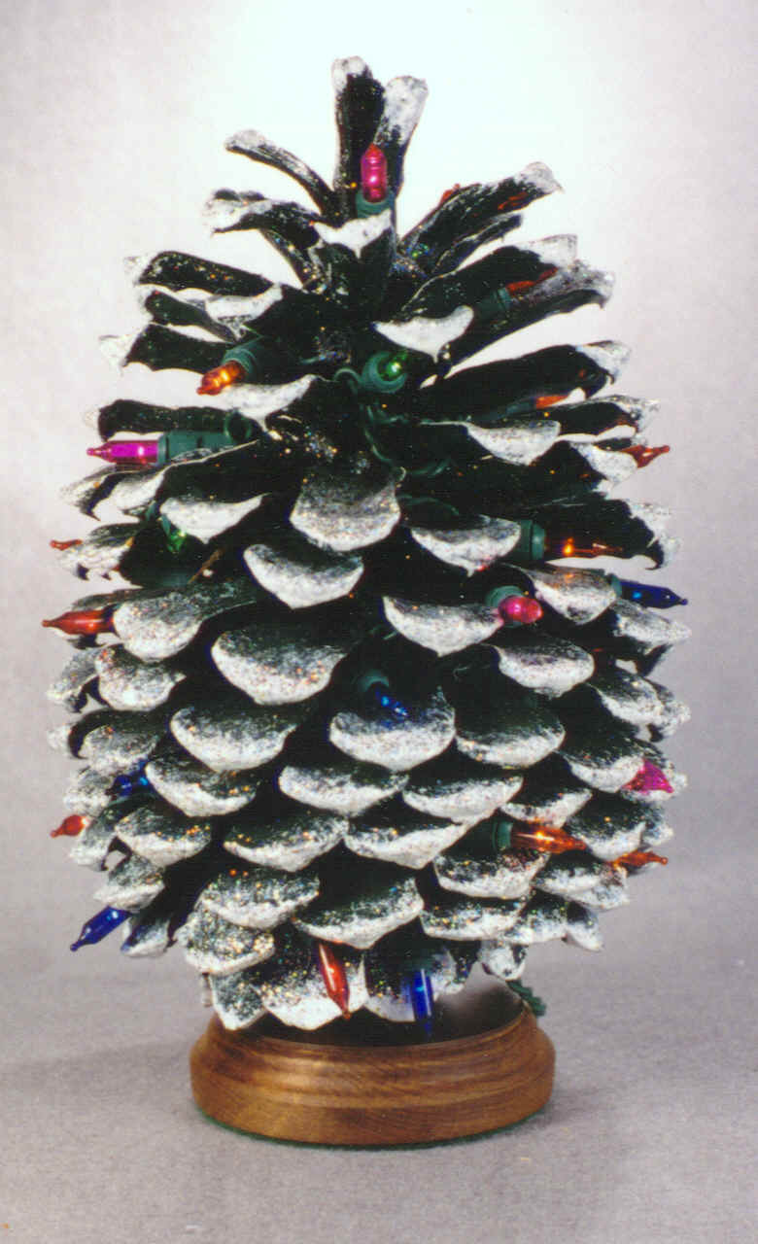
Everyone also made a fir cone Christmas tree, you could add some wire to it & hang it on your Christmas tree or you can simply stick it in a piece of blutac & position it on a window sill or shelf. We also enjoyed making the Muller yoghurt pots (thanks for all the pots!) with painted & glittered branches in them. We think they make a lovely table decoration & hope that lots of you will be eating your Christmas dinner with that as your centre piece!

The children all have a Christmas plate, we think they are absolutely beautiful hanging on the lines in the classroom – each one is so individual & unique.
Yesterday we were very busy and everyone decorated their own Christmas fairy cake – we had edible glitter & sprinkles from one end of the classroom to the other. We managed to get them all bagged up & home to you in the same day! Enjoy!
We hope to have all the artwork into the wallets by Monday afternoon so please check your child’s wallet & tray daily.

Santa is visiting Harrison ...
Santa from the charity ‘Love for Life’ is visiting Harrison on Monday morning. They request £6 per child with all the money going towards their charity work with schools in Northern Ireland. Please feel free to look at their website for more information about what they do in our community –
www.loveforlife.org.uk
Santa & an elf will be coming into school & using our ‘Christmas room’ to meet the children in small groups. We will take a photograph of each child & print it out for you. Each child receives a present. We would appreciate if the money is with us by Friday (16th December) so that we have it all sorted to give to ‘Love for Life’ on Monday.
IF YOUR CHILD IS AFRAID OF SANTA THEY WILL NOT HAVE TO GO TOO CLOSE & CAN STILL GET THEIR PRESENT!


Many thanks for all the contributions of toilet rolls, tissues & ‘Dove’ liquid soap. If you haven’t contributed yet they are very welcome at any time.

Last days of school
On the last day please ensure you take everything off your child’s peg i.e. coat, change of clothes bag etc. This leaves the cloakroom area more accessible for cleaning.
Monday & Tuesday are school days & the children are requested to wear school uniform as normal.
School finishes on Tuesday evening (see below) & we start back on Tuesday 3rd January 2012 at 8.45am (and breakfast club from 8am).

Application forms for Primary Schools
In early January please ensure you have contacted your preference Primary School & collected an application pack. The closing date for Primary School applications is Wednesday 18th January 2012 at 12 noon. It is VERY important that this form is completed & returned on time.


MR HULLABALOO
To mark Christmas & the end of term 1 Mr Hullabaloo is visiting Harrison (take a look at his website for more information about his performances – www.mrhullabaloo.co.uk). We will have 2 performances, Mrs Edwards’ class are invited to attend at 4pm & Mrs Hunter’s class at 6pm. We envisage it will last 1 ½ hours approximately. Siblings are welcome to attend as well & initially we had specified 2 guests per child but if you would like to bring an extra one or two just let us know so that we have an idea of numbers. Mrs Hunter will send a text for you to reply to with numbers attending. Please do not worry if it is not convenient for you to come to this event, you can simply let us know if you are not attending when you text back. During the whole event you will be responsible for your children. To cover the cost of the meals kitchen catering please pay £5.70 dinner money on Monday morning. The children can wear their own clothes & we look forward to seeing the various outfits on Tuesday evening!

HAPPY CHRISTMAS FROM EVERYONE AT HARRISON.
MANY THANKS FOR ALL YOUR HELP & SUPPORT DURING TERM 1 & WISHING YOU & YOUR FAMILY A PROSPEROUS 2012.


